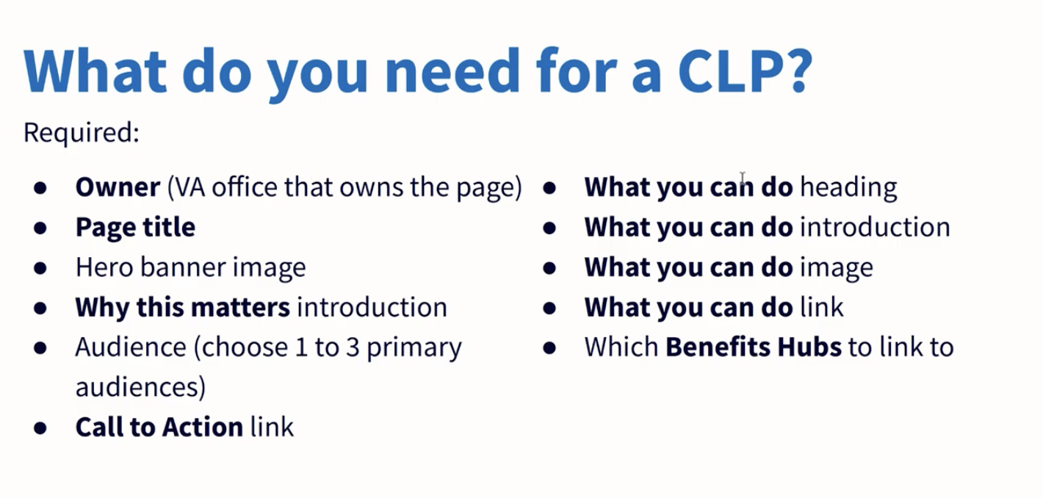

**\*\*REQUIRED\*\***

**Owner:** Office of the Chief Technology Officer - Digital Experience

**Page Title:** Sign in securely with Login.gov

[scroll down for hero banner options]

[CTA: Create a free Login.gov account] (https://api.va.gov/v1/sessions/logingov_signup/new)

**Why this matters**

**Introduction:** We are improving our sign-in process on VA.gov to meet the latest federal security standards and keep your information safe. Login.gov is now the recommended option for securely signing in to manage VA health care and benefits online.

**Audience:** All Veterans, Family Members and Caregivers

**Call to Action Link:** Create a Login.gov account (link to Login.gov account creation page)

**What you can do**

**Heading:** Use Your Login.gov account to sign in to VA.gov

**Introduction:**

With a Login.gov account, you’ll be able to access your VA health care and benefits online— in addition to a growing list of other federal government websites. Create a Login.gov account today and then use it to sign in to VA.gov. After you sign in to VA.gov with Login.gov, we’ll ask you to verify your identity.

**Image:**

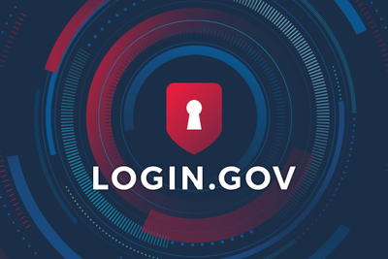

**Link:** Create a Login.gov account (link to Login.gov account creation page)

VA BENEFITS

**Header**: Learn more about VA benefits

**Link**: [VA health care](https://www.va.gov/health-care/) and [VA education and training benefits](https://www.va.gov/education/)



**\*\*ADD-ON’S\*\***

FAQ

**Frequently asked questions**

OUTREACH MATERIALS

**Account Creation Guide**

**TAP Curriculum**

**Video**

NEWS AND UPDATES

**BLOG 1**

**BLOG 2: Changing Security Landscape**

**BLOG 3: Securely accessing your VA account online (by VBA)**

HELPFUL LINKS

**Existing FAQs**

**Login.gov Help Center**

CONNECT WITH US

**Get updates from Veterans Affairs**

[VACO Email Updates](https://public.govdelivery.com/accounts/USVA/subscriber/new/)

[Veterans Affairs Twitter](https://twitter.com/DeptVetAffairs)

[Veterans Affairs Facebook](https://facebook.com/VeteransAffairs)

[Veterans Affairs YouTube](https://youtube.com/DeptVetAffairs)

[Veterans Affairs Instagram](https://instagram.com/deptvetaffairs)